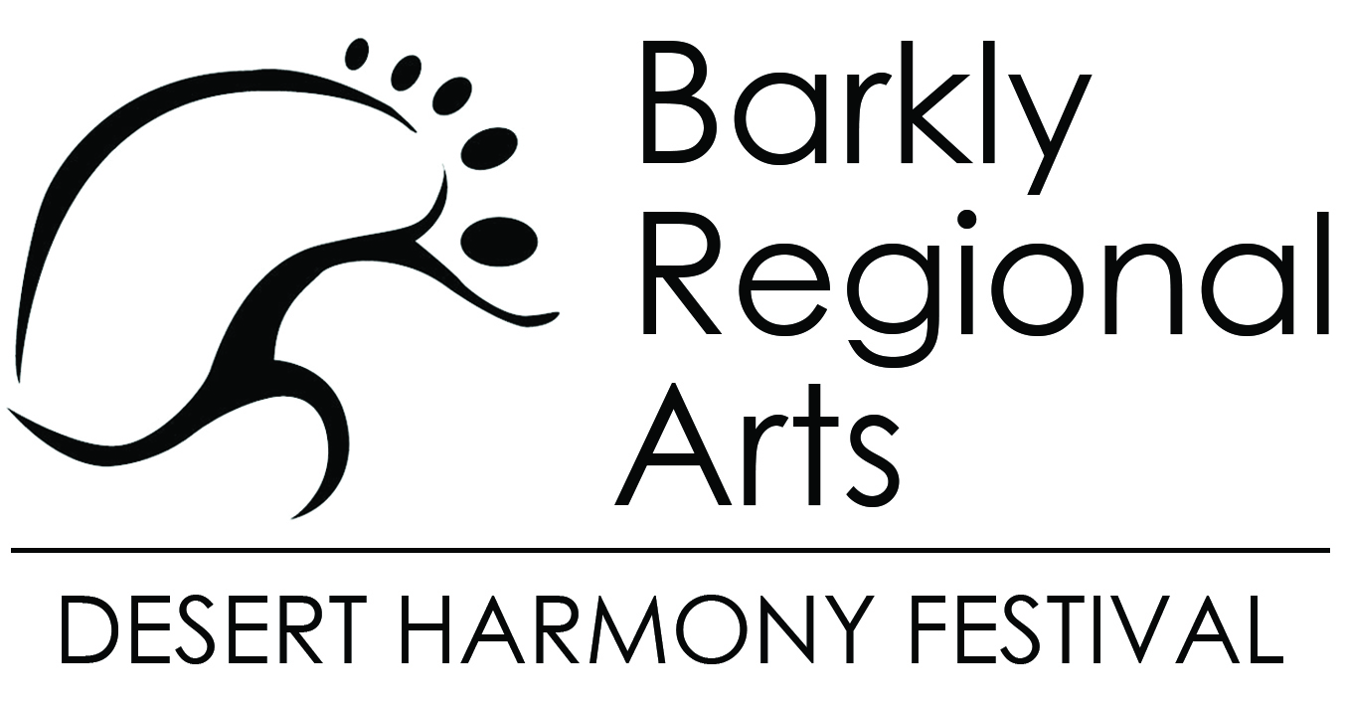

Showcasing work
The Desert Harmony Festival is a platform for all people in the Barkly to have work showcased to a large and broad audience. Our particular focus is arts and culture, though we would be happy to explore other ideas too.

Works do not have to be professional. This is a community Festival and everyone deserves to have the chance to show off their work.

Name
Contact phone
Email
Postal address
What would you like to showcase? | Please describe what it is
What support do you need?
(example: hanging walls, table, marquee, power)
How many days in the Festival do you want to showcase work
(1-4 days)
Which day/s would you like | Friday Saturday Sunday Monday
What kind of space do you require? (indoor,outdoor, 3m x 3m etc)
Please write a short outline of your showcase work for marketing purposes (no more than 200 words)

Please email to Kathy Burns
E | artisticdirector@barklayrts.com.au
P | 08 8962 2799

